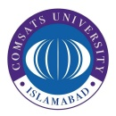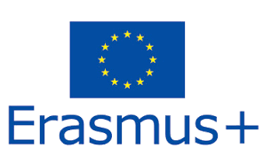
Call for Applications
One Erasmus+ Fully funded Mobility (Faculty) at Middle East Technical University (METU), Turkey

Applications are invited from Architecture & Design faculty members for one week mobility at METU.

Eligibility:
Full time Architecture faculty member desirous of teaching at host university. Good English language skills required with minimum proficiency level of B2.

Funding: Daily grant of 140 Euro and International airfare.

For checking Host University, its departments & programs and courses visit
https://catalog.metu.edu.tr/
http://www.metu.edu.tr/faculties-institutes-schools
How to Apply:
Submit filled in application form along with required documents to the contact person before Ist October, 2019

Contact Person:
Name: Ms. Nida Jawad
Title/Designation: Head, Architecture & Design, CUI
E-mail: nidajawad@comsats.edu.pk
Phone# (+92)3324252666

